ROBOTIC ARM : EXOGENESIS

Introduction
In recent years, robotic systems have gained importance in medical, industrial, and educational fields. A robotic hand that mimics human finger movements can be useful in rehabilitation, prosthetics, automation, and research. This project focuses on designing and developing a wireless robotic hand using flex sensors and ESP32 microcontrollers. The system captures finger movements using flex sensors mounted on a glove and transmits the data wirelessly to a robotic hand. The robotic hand then replicates the same movements using servo motors.

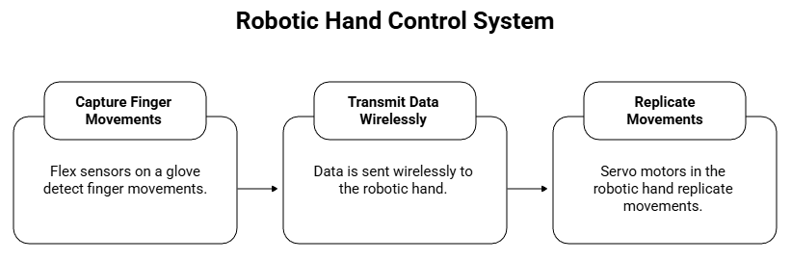

Objectives of the Project
The main objectives of this project are:
- To design a wearable glove using flex sensors for motion detection.
- To transmit finger movement data wirelessly using ESP-NOW.
- To control servo motors for realistic finger movement.
- To build a low-cost and efficient robotic hand system.
- To ensure reliable and real-time performance.

System Overview
The system is divided into two main parts:
- Sender Unit (Glove Side)
- Receiver Unit (Robotic Hand Side)
1. Sender Unit
The sender unit consists of:
- ESP32 microcontroller
- Flex sensors
- Voltage divider circuit
- Power supply
It reads the resistance of flex sensors and converts it into digital values.
2.Receiver Unit
The receiver unit consists of:
- ESP32 microcontroller
- Servo motors
- Robotic hand structure
- Power supply
It receives wireless data and controls the servo motors accordingly.

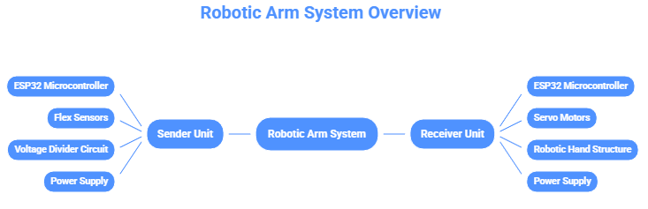

Hardware Components
1 ESP32 Microcontroller
- Dual-core processor
- Built-in WiFi and Bluetooth
- Supports ESP-NOW protocol
- Low power consumption
2 Flex Sensors
- Resistance varies with bending
- Used for detecting finger movement
- Connected using voltage divider
3 Servo Motors
- Used to control finger movement
- Angle range: 0° to 180°
- Controlled using PWM signals
Software Requirements
- Arduino IDE
- ESP32 Board Package
- ESP32Servo Library
- ESP-NOW Library
Working Principle
- Flex sensors change resistance when bent.
- ESP32 reads analog values using ADC.
- Resistance is calculated using voltage divider formula.
- Noise is reduced using smoothing techniques.
- Finger states (bent/flat) are determined using hysteresis logic.
- Data is transmitted using ESP-NOW.
- Receiver ESP32 receives data.
- Servo motors rotate according to received values.
- Robotic hand mimics human hand movement.

Code Implementation and Hardware Setup
1 Sender (Glove Unit) Code
The sender unit reads flex sensor values, processes them, and transmits data wirelessly using ESP-NOW.
Main Functions:
- Reads analog values from flex sensors
- Applies smoothing and hysteresis
- Calculates resistance
- Sends finger states to receiver
(Refer to project source code for complete implementation.)
2 Receiver (Robotic Hand Unit) Code
The receiver unit receives data and controls servo motors accordingly.
Main Functions:
- Initializes ESP-NOW
- Receives finger state data
- Controls servo motors using PWM
- Implements safety timeout
(Refer to project source code for complete implementation.)
3 Software Setup Procedure
- Install Arduino IDE.
- Install ESP32 board package.
- Install ESP32Servo library.
- Connect ESP32 to computer.
- Select correct COM port and board.
- Upload receiver code first.
- Note down MAC address.
- Update sender code with receiver MAC.
- Upload sender code.
- Open Serial Monitor for debugging.
4 Hardware Connections
Flex Sensor Connections (Sender)
- One end of flex sensor → 3.3V
- Other end → Analog Pin (GPIO)
- Fixed resistor (200kΩ) → Ground
- Voltage divider output → ESP32 ADC pin
Servo Motor Connections (Receiver)
- Red wire → 5V external supply
- Brown/Black wire → Ground
- Yellow/White wire → ESP32 PWM pin
- Common ground between ESP32 and power supply

Power Supply
- ESP32 powered via USB or 5V regulator
- Servos powered using external 5V supply
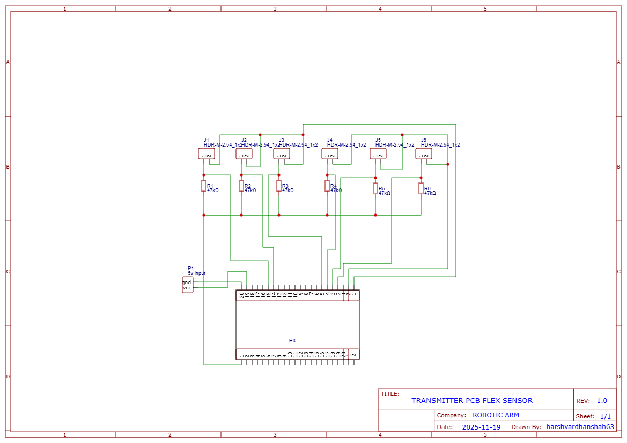
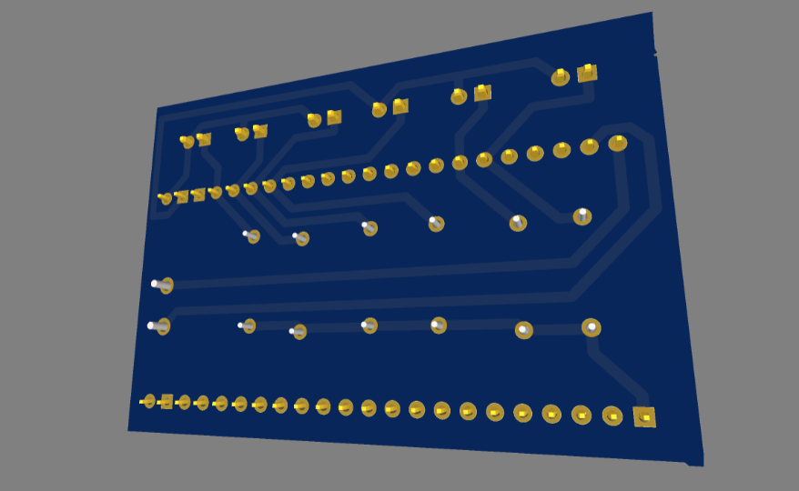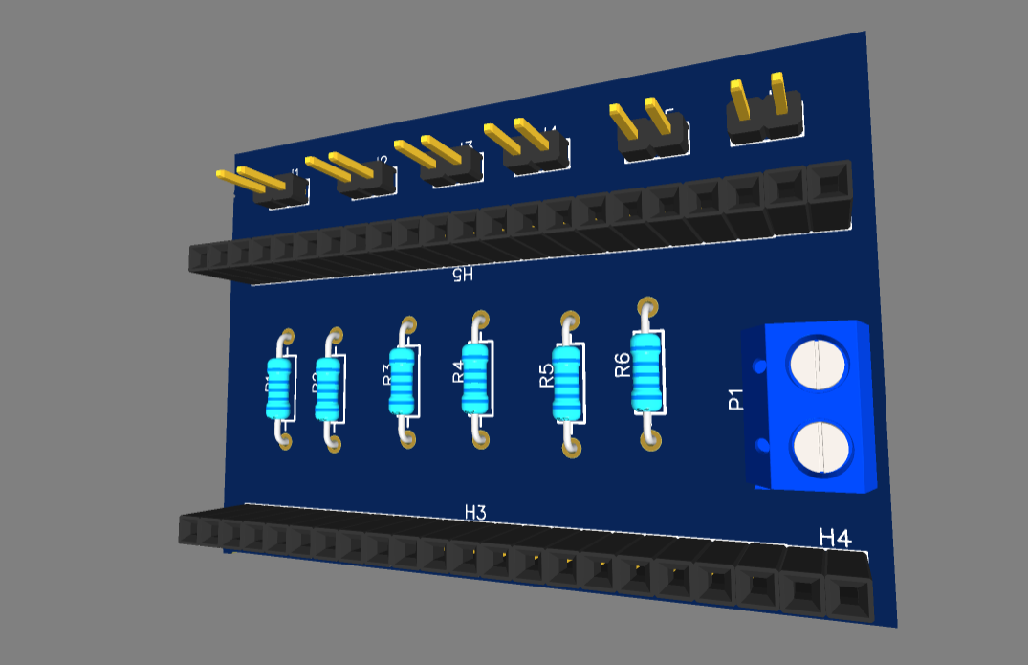
5 System Setup Steps
- Mount flex sensors on glove fingers.
- Fix servo motors on robotic hand structure.
- Connect all sensors and motors.
- Verify power connections.
- Upload codes.
- Test individual finger movement.
- Calibrate resistance values.
- Perform wireless testing.
- Final system integration.
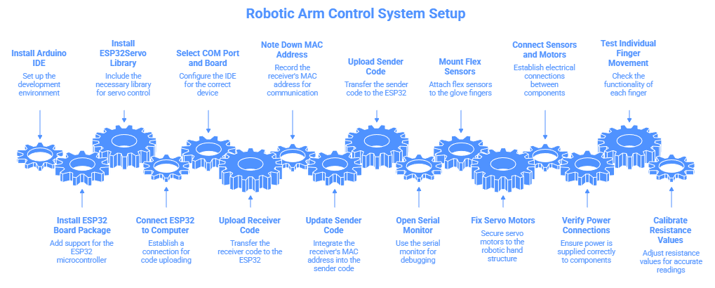
Flowchart
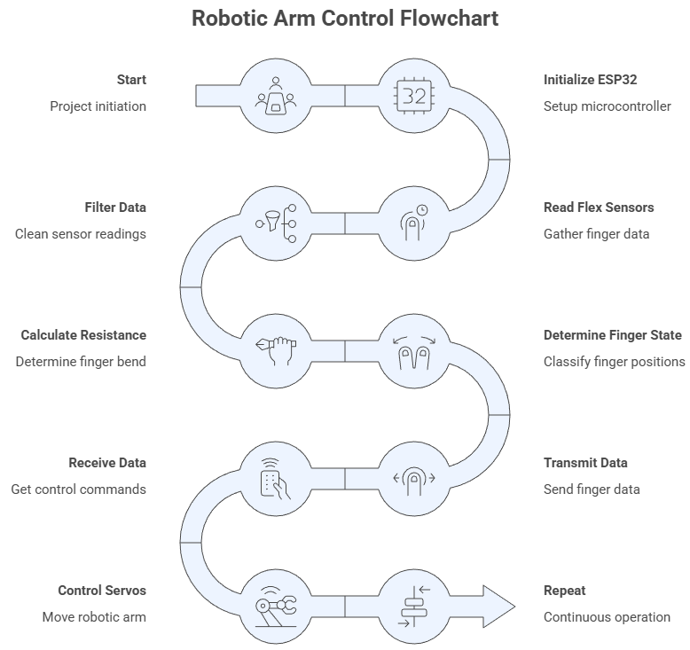

Communication Method (ESP-NOW)
ESP-NOW is a low-latency wireless communication protocol developed by Espressif. It enables peer-to-peer communication without using a router.
Features:
- Low delay
- Low power
- High reliability
- No internet required
Algorithms Used
1 Smoothing Algorithm
Moving average filter is used to reduce noise in sensor readings.
2 Hysteresis Algorithm
Two thresholds (R_LOW and R_HIGH) are used to prevent frequent switching.
3 Servo Control Algorithm
Finger states are mapped to servo angles for realistic movement.

Results and Observations
- The robotic hand accurately follows human finger movements.
- Wireless transmission is stable within 20–30 meters.
- System response time is less than 50 ms.
- Power consumption is moderate.
- System is reliable for continuous operation.
Applications
- Prosthetic hand control
- Rehabilitation systems
- Human–machine interaction
- Robotics research
- Educational projects
Advantages
- Low cost
- Wireless operation
- Real-time control
- Portable
- Easy to modify
Limitations
- Limited range
- Requires calibration
- Sensitive to noise
Future Scope
- Mobile app control
- AI-based gesture recognition
- Haptic feedback
- Cloud monitoring
References
- ESP32 Datasheet – Espressif Systems
- Arduino Official Documentation
- ESP-NOW Programming Guide
- Robotics and Sensor Technology Books
- ESP32 Datasheet – Espressif Systems
- Arduino Official Documentation
- ESP-NOW Programming Guide
- Robotics and Sensor Technology Books
Conclusion
This project successfully demonstrates the design and implementation of a wireless robotic hand using ESP32 and flex sensors. The system is efficient, low-cost, and suitable for academic and research purposes. It provides a strong foundation for advanced robotic and prosthetic applications.

YOUTUBE VIDEOS LINK TESTING AND PROTOTYPE
- https://youtube.com/shorts/7Oa2iwueIwg?si=Fzh45fDLNvpiwW9M
- https://youtube.com/shorts/HdQvleQe6Do?si=t_su_lGh6K9XxUNW
LINKEDIN POST
- https://www.linkedin.com/posts/harshvardhanshah63_robotics-embeddedsystems-hardwareprojects-activity-7410461919540752384-7Hrv?utm_source=social_share_send&utm_medium=android_app&rcm=ACoAAF4nhrcB4VpFJhVOthZDY2YUtMuMLE54Vss&utm_campaign=copy_link
- https://www.linkedin.com/posts/harshvardhanshah63_roboticsdemo-mechatronics-esp32-activity-7410465693500022785-tMFq?utm_source=social_share_send&utm_medium=android_app&rcm=ACoAAF4nhrcB4VpFJhVOthZDY2YUtMuMLE54Vss&utm_campaign=copy_link
GITHUB REPOSITORY
https://github.com/harshvardhanshah63/Robotic-Arm-Esp-Now-Flex-Sensor-
PRODUCT IMAGES
